Dear Parents,

Over the weekend some schools in Wrexham have seen a marked uptick in cases of COVID-19, particularly amongst pupils. There is further advice on its way to schools around when to seek support if cases reach certain trigger points and that should be with us towards the end of this week.
As you know, the current government advice is that under 18s do not need to self-isolate even if there are cases in their close family. This does mean that pupils may be sent into school in such circumstances, and there are no plans to change that policy locally at present.
However, in the event of a positive case, where there are close contacts, individuals are being contacted by TTP and are being asked to undertake PCR tests on day 2 and day 8.
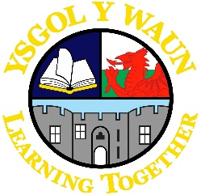 | Ysgol Y Waun  Chapel/ Lloyds Lane  Chirk  Wrexham  LL145NH  Monday 13th September 2021
The process of identifying close contacts is much more difficult with younger pupils, therefore, from today we are to assume that all Foundation Phase and Year 3 and 4 pupils have been close contacts and school will send parents a letter or SMS message encouraging the use of LFD tests, whilst at the same time encouraging continued attendance at school.
It is important to note that we are not advocating the re-instatement of bubbles within school which have already been collapsed, nor are we suggesting that whole year groups isolate following a positive case. We are just recommending a more proactive approach to informing parents.

Yours sincerely,

J. Roberts

