
YSGOL Y WAUN – NEWSLETTER
Friday 22nd October 2021
www.ysgolywaun.co.uk

THANK YOU
May we take this opportunity to thank all of our pupils for their hard work, dedication and commitment to their school work this term – well done everyone! A big thank you also to all parents and family members for your support.

We wish you a safe and healthy half term and look forward to seeing you back on Monday, 1st November.

COVID
On our return to school after half term please keep following Covid Guidelines –

Do not send your child to school if they have any of the 3 core symptoms
- new continuous cough
- fever (37.8 temperature and above),
- loss of sense of taste and or smell)

If your child displays any of these symptoms please arrange a PCR test and inform school either by a Seesaw message to your child’s class teacher or an email to mailbox@ywaun-pri.wrexham.sch.uk. Please also remember to send the confirmation negative / positive message to school once you receive this.
If you require guidance on your child’s symptoms please give the Covid helpline a call on 119 for advice.
Thank you all for your co-operation in keeping us all as safe as possible.

HARVEST DONATIONS
A big, big thank you to our fantastic families for your kind donations of food items for the Oswestry Food Bank. We, and the volunteer from the Food Bank who came to collect are totally overwhelmed by the amount donated! Thank you all for your wonderful support for this very worthwhile organisation !!

OUT OF SCHOOL SPORTING CLUBS / ACTIVITIES

Please see the additional documents dated 2^{2nd} October re out of school sports club / activities being run locally that you may be interested in.
- Moreton Hall Tennis Club
- Fire Service Colouring Competition

HEADTEACHER AWARDS
FRIDAY 22nd October 2021

 | CLASS | NAME | REASON
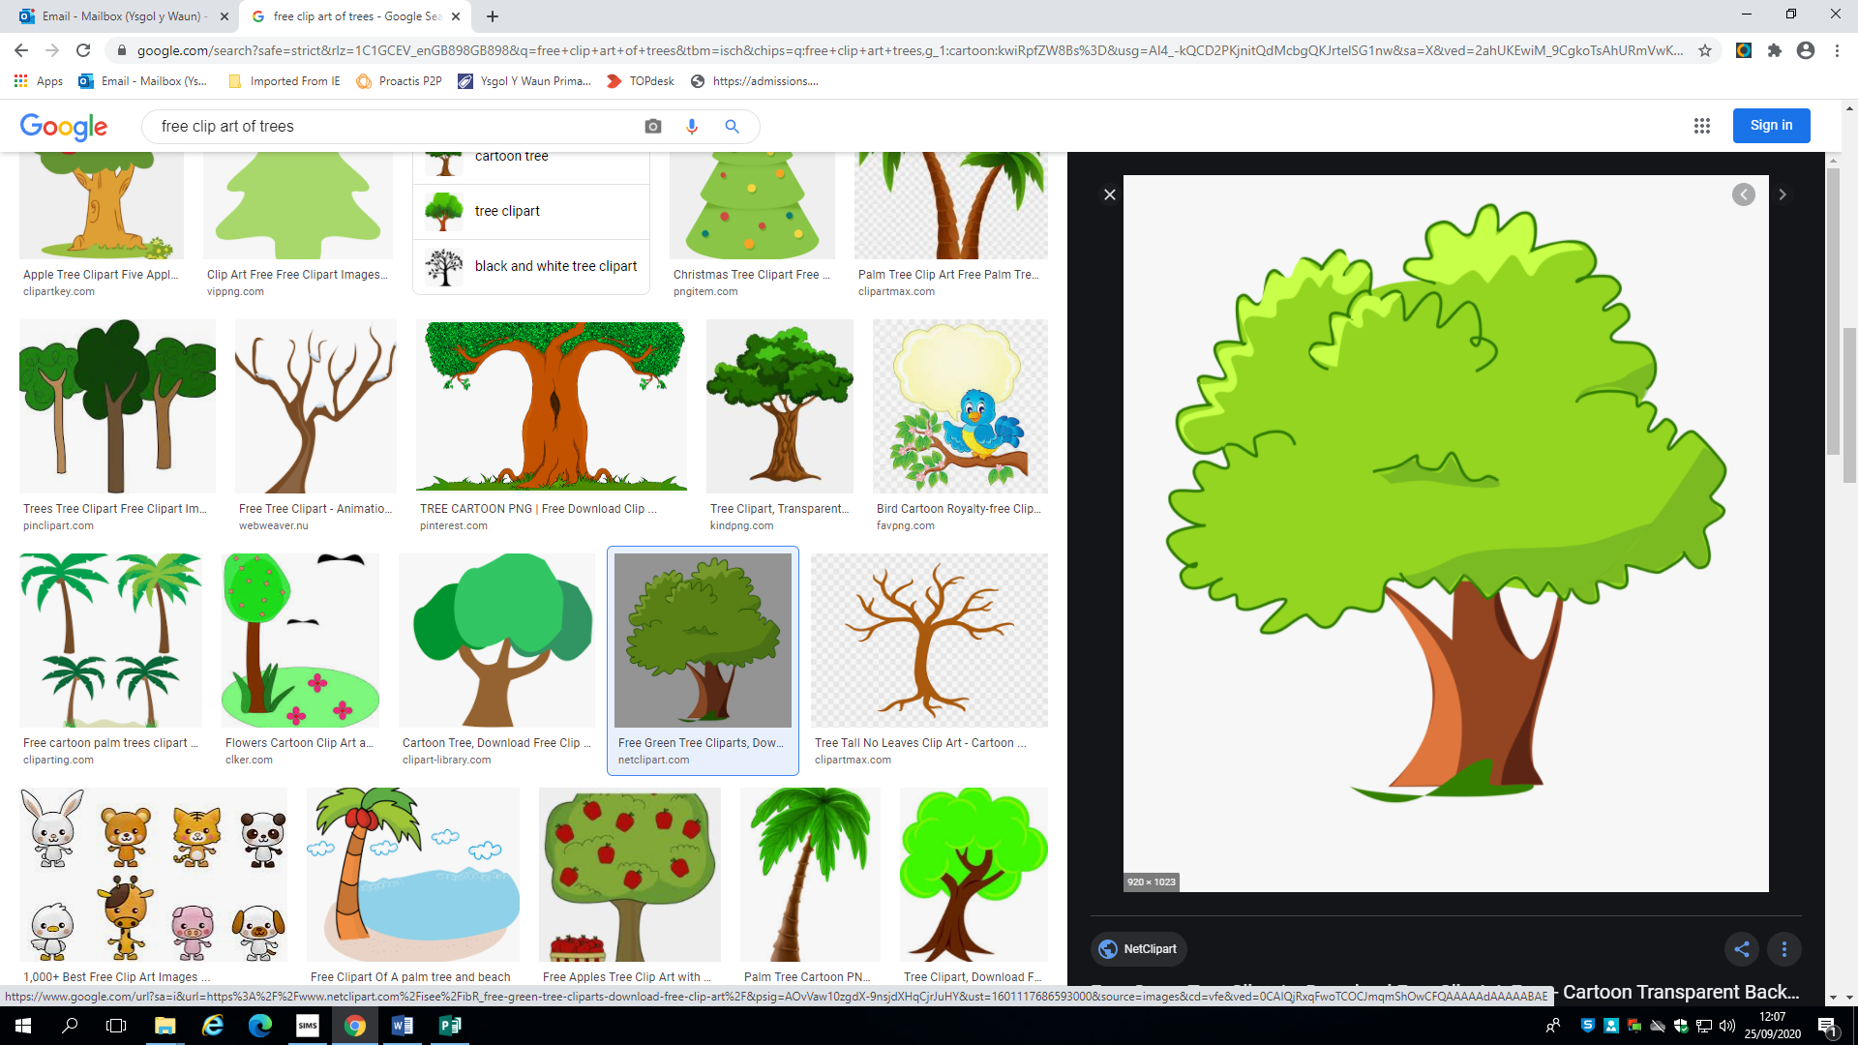 | ELM | Isaac Hopwood | For fantastic ideas and descriptions towards our Autumn poem. Da iawn.
 | MAPLE | Belle Clarke | For creating a beautiful Autumn painting of a tree. Da iawn Belle!
 | WILLOW | Miller Pearce-Pugh | For creating a beautiful Autumn painting. Bendigedig!
 | JUNIPER | Harper Kendrick | For wonderful singing and setting a great example.
 | HAZEL | Lola Tinsley | For writing a brilliant set of instructions. Da iawn Lola.
 | SYCAMORE | Reggie Tudor | For an amazing forest description and brilliant 3 digit by 3 digit additions.  Bendigedig
 | PINE | Beatrice Jones | For writing an excellent forest description using similes, -ly openers and 2A sentences. Fantastic!
 | CHERRY | Dane Williams | For an incredible PowerPoint presentation on European landmarks  Bendigedig!
 | EBONY | Ege Acun | For his enthusiasm in topic work when making his American tourist poster  Da iawn!
 | CEDAR | Logan Carter | For fantastic column addition work in maths.  Bendigedig!
 | SILVER BIRCH | Archie Williams | For his amazing effort in maths and trying every way possible to solve a question. Fantastic!
 | BEECH | Olivia Pugh | For her amazing views on apartheid and class discussions.  Excellent!

DATES FOR YOUR DIARIES FOR THIS SCHOOL YEAR

AUTUMN TERM

Monday 1st November 2021 – School Opens for Autumn 2nd Half Term

Tuesday 21st December 2021 – School Closes for Christmas Holiday

Wednesday 22nd December 2021 – Additional Bank Holiday for ‘Queens Platinum Jubilee’

SPRING TERM

Thursday 6th January 2022 – Training Day for Teachers

Friday 7th January 2022 – Training Day for Teachers

Monday 10th January 2022 – School Opens for Spring 1st Half Term

Friday 18th February 2022 – School Closes for Spring Half Term Holiday

Monday 28th February 2022 – School Opens for Spring 2nd Half Term

Friday 8th April 2022 – School Closes for Easter Holiday

SUMMER TERM

Monday 25th April 2022 – Training Day for Teachers

Tuesday 26th April 2022 – School Opens for Summer 2nd Half Term

Monday 2nd May 2022 – School Closed for May Bank Holiday

Friday 27th May 2022 – School Closes for Summer Half Term Holiday

Monday 6 th June 2022 – School Opens for Summer 2nd Half Term

Tuesday 19th July – School Closes for Summer Holidays

