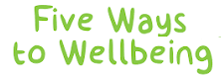
We realise lives are so busy at home and it can sometimes be a juggling act to spend quality time with your children and family. We at Ysgol y Waun would like to encourage you to think about the…

The children have been working on these, year upon year and really developing their understanding of what helps keep their mind happy and healthy each day.
Over this next term we would like to encourage you to work on these with your children at home.
We would love to see some pictures of them engaging in perhaps, being ‘Active’ or ‘Connecting’ with friends and family over a weekend. Please send any examples of the 5 Ways to Wellbeing to your class Teacher via Seesaw.
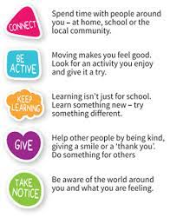

Each night we would also encourage you to really support your child with their reading and enjoy their reading book together. Reading is so crucial to their learning and development and really supports their life, long love of books. We appreciate this again can sometimes be tricky but do feel getting into a routine at the start of the term really does help.
There will also be some exciting competitions and lots more fun to come this term.
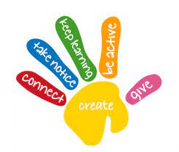
Diolch for your continued support.

Mrs Morgan

